

**PolyFace Dashboard**

**Software Analysis Standards**

**Requirements/Analysis Specification (RAS)**

**Version 1.1**

Document Number: RAS-001

Project Team Number: B5

Project Team members:

Basia Bowens 0409049 ([bbowen01@students.poly.edu](mailto:bbowen01@students.poly.edu))

Wendy Lau 0402381 ([wlau01@students.poly.edu](mailto:wlau01@students.poly.edu))

Wayne Jones 0406890 ([wjones01@students.poly.edu](mailto:wjones01@students.poly.edu))

**REVIEW AND APPROVALS**

|  |  |  |  |
| --- | --- | --- | --- |
| **Printed Name and Title** | **Function (Author, Reviewer, Approval)** | **Date** | **Signature** |
| Professor Strauss | Author | February 21st 2013 |  |
|  |  |  |  |
|  |  |  |  |
|  |  |  |  |
|  |  |  |  |
|  |  |  |  |
|  |  |  |  |

**REVISION LEVEL**

|  |  |  |
| --- | --- | --- |
| **Date** | **Revision Number** | **Purpose** |
| February 19th 2013 | Version 1.0 | Initial Release |
| February 21st2013 | Version 1.1 | Fixed some faults in the documentation |
|  |  |  |
|  |  |  |
|  |  |  |
|  |  |  |
|  |  |  |

**TABLE OF CONTENTS**

**1. INTRODUCTION ................................................................................................................................ 7**

**1.1 PURPOSE ......................................................................................................................................... 7**

**2. SCOPE ................................................................................................................................................... 7**

**2.1 IDENTIFICATION.............................................................................................................................. 7**

**2.2 BOUNDS .......................................................................................................................................... 7**

**2.3 OBJECTIVES .................................................................................................................................... 7**

**2.4 SYSTEM OVERVIEW ........................................................................................................................ 8**

**2.5 DOCUMENT OVERVIEW................................................................................................................... 8**

**3. REFERENCE DOCUMENTS............................................................................................................. 9**

**4. BUSINESS REQUIREMENTS ........................................................................................................... 9**

**4.1 TECHNOLOGY ................................................................................................................................. 9**

**4.2 ECONOMICS .................................................................................................................................... 9**

**4.3 REGULATORY AND LEGAL .............................................................................................................. 9**

**4.4 MARKET CONSIDERATIONS ............................................................................................................ 9**

**4.5 RISKS AND ALTERNATIVES ............................................................................................................. 9**

**4.6 HUMAN RESOURCES AND TRAINING............................................................................................... 10**

**5. DESCRIPTIVE FUNCTIONAL AND NON-FUNCTIONAL REQUIREMENTS........................ 10**

**5.1 SYSTEM’S PURPOSE ........................................................................................................................ 10**

**5.2 FUNCTIONAL DESCRIPTIVE DETAILED REQUIREMENTS.................................................................. 10-11**

**5.3 NON-FUNCTIONAL DESCRIPTIVE DETAILED REQUIREMENTS......................................................... 11**

**5.4 CONTEXT DIAGRAM........................................................................................................................ 11**

**6. FUNCTIONAL REQUIREMENTS ANALYSIS SPECIFICATION.............................................. 11**

**6.1 SYSTEM CAPABILITY REQUIREMENTS ............................................................................................ 11**

***6.1.1 Capabilities................................................................................................................................11-12***

**6.2 USER INTERFACE REQUIREMENTS .................................................................................................. 12**

**6.3 COMPONENT ARCHITECTURE.......................................................................................................... 12**

***6.3.1 Component Descriptions ........................................................................................................... 12-13***

***6.3.2 Component Architecture Diagram ............................................................................................ 13***

**6.4 CLASS DIAGRAMS........................................................................................................................... 14**

**6.5 CLASS RELATIONSHIP/INTERACTION DIAGRAMS............................................................................ 15**

**6.6 EVENT SECTION .............................................................................................................................. 15**

***6.6.1 Event Dictionary........................................................................................................................ 15-16***

***6.6.2 Event Diagrams......................................................................................................................... 17-18***

**6.7 ACTIVITY/STATE (SCENARIO) SECTION (TO BE COMPLETED IN DESIGN)........................................ 19**

***6.7.1 Activity (Scenario) Diagrams.................................................................................................... 19***

***6.7.2 Activity (Scenario) Specification ............................................................................................... 19***

**6.8 SEQUENCE DIAGRAMS .................................................................................................................... 20**

**6.9 COLLABORATION DIAGRAMS.......................................................................................................... 20**

**6.10 DICTIONARIES................................................................................................................................. 20**

**7. NON-FUNCTIONAL/OPERATIONAL REQUIREMENTS........................................................... 20**

**7.1 SYSTEM EXTERNAL INTERFACE REQUIREMENTS............................................................................ 20**

**7.2 SAFETY REQUIREMENTS ................................................................................................................. 20**

**7.3 SECURITY AND PRIVACY REQUIREMENTS....................................................................................... 21**

**7.4 SYSTEM ENVIRONMENT REQUIREMENTS........................................................................................ 21**

**7.5 COMPUTER RESOURCE REQUIREMENTS.......................................................................................... 21**

***7.5.1 Computer Hardware Requirements........................................................................................... 21***

***7.5.2 Computer Hardware Resource Requirements........................................................................... 21***

***7.5.3 Computer Software Requirements............................................................................................. 21***

***7.5.4 Computer Communications Requirements................................................................................ 21***

**7.6 SYSTEM QUALITY FACTORS ........................................................................................................... 21**

**7.7 DESIGN AND CONSTRUCTION CONSTRAINTS .................................................................................. 21-22**

**7.8 PERSONNEL-RELATED REQUIREMENTS .......................................................................................... 22**

**7.9 TRAINING-RELATED REQUIREMENTS ............................................................................................. 22**

**7.10 LOGISTICS-RELATED REQUIREMENTS ............................................................................................ 22**

**7.11 PACKAGING REQUIREMENTS .......................................................................................................... 22**

**7.12 PRECEDENCE AND CRITICALITY REQUIREMENTS ........................................................................... 22**

**7.13 OTHER REQUIREMENTS .................................................................................................................. 22**

**8. SYSTEM TEST PLAN REQUIREMENTS ....................................................................................... 22-23**

**9. QUALIFICATION PROVISIONS ..................................................................................................... 23**

**10. REQUIREMENTS TRACEABILITY ........................................................................................... 23-24**

**11. RATIONALE.................................................................................................................................... N/A**

**12. NOTES............................................................................................................................................. N/A**

**13. APPENDICES................................................................................................................................... 24**

**13.1 DICTIONARIES ...................................................................................................................................... 24**

**13.2 UML DIAGRAMS, IF NOT INCLUDED IN THE BODY OF THE DOCUMENT ................................................. 24**

**13.3 SCHEDULE TRACKING .......................................................................................................................... 24-25**

**13.4 DEFECT TRACKING............................................................................................................................... 25-26**

**1. INTRODUCTION**

**1.1 Purpose**

The purpose of this document is to provide a combination of system requirements and software analysis specifications. This document will outline the requirements of the client. Below, we will identify the business requirements, logical architectural specification, non-functional/operational specifications and system test plan requirements.

**2. SCOPE**

**2.1 Identification**

PolyFace, Requirements/Analysis Specification (RAS), Version 1.1, February 21th, 2012

**2.2 Bounds**

As mentioned previously in the PolyFace SRS, boundaries that will be limiting the developer’s options will be deadlines, reliability, and safety and security. Deadlines are a part of every project that developers usually stress to meet. If deadlines are not met, the project cannot run efficiently and smoothly. Reliability of our product depends on both developers and user feedback. Developers are expected to produce a product that meets the clients’ needs which in this case, is to provide users of the university with accurate information and interaction opportunities. This can be done most proficiently with user feedback and metrics. Safety and security is one of the most critical constraints of a project, especially in web development. With an expected number of users, we must be able to protect user’s personal information and also assure that the dashboard environment will not be harming. The budget will be the greatest constraint placed on the project. The team will have to plan according to the budget, in order to make sure that the project has the means to be completed.

**2.3 Objectives**

The project priority is to provide the NYU-Poly community with accurate information on events. The PolyFace dashboard will be a reliable source to the students and will hopefully increase the attendance to events. Our developers will utilize the Unified Process as our primary methodolgy and operate as a democratic team

**2.4 System Overview**

Due to the lack of participation and attendance to campus activities, our team believes that a unified source of consolidated information is needed for the NYU-Poly organization.

The “PolyFace” dashboard will consolidate all event information and to make it accessible to students. Using the dashboard, students will be able to view all events that are occurring on campus or narrow their results by subscribing to specific event categories. Categories such as academic, social and opportunity will be available for subscription. With the PolyFace dashboard, students will be able to keep up to date on upcoming events that

pertain to their interests, therefore increasing student attendance and also improving student life. “PolyFace” is a standalone system and is not a part of a larger entity.

**2.5 Document Overview**

This document will contain:

Introduction and Scope: An introduction to the documentation as well as its scope including boundaries and objectives

Business Requirements: The business drivers pertaining to Technology, Economics, Regulatory and Legal, Market Considerations, Market Considerations, Risks and Alternatives and Human Resources and Training.

Logical Architectural Specification: This section contains diagrams of boundaries, use cases, the component architecture, class relationship/interactions, events, sequences and collaborations. It will also describe the system capability requirements, component descriptions, events to which the system responds to, motives and definitions of classes, methods, attributes, events, etc.

Non- Functional/Operational Specifications: This section contains the detailed requirements of the system external interface, safety, security/privacy, system environment, computer resources, computer hardware, computer software, computer communications, system quality, personnel, training, logistics, packaging, and precedence/criticality.

System Test Plan Requirements: Test plans with scenario testing and required simulators will be provided in this section

Qualification Provisions: A description of the product quality process and review will be stated

Requirements Traceability: This section will serve as a traceability of requirements previously mentioned and noted by members of the team

**3. REFERENCE DOCUMENTS**

PolyFace, Project Proposal, Version 1.1, February 4th, 2013  
PolyFace, SRS, Version 1.0 (initial), October 23, 2012

PolyFace, SRS, Version 1.1 (final), October 26, 2012

PolyFace, SPMP, Version 2.1, February 21st, 2013

PolyFace, SAS, Version 1.0, December 2, 2012

**4. BUSINESS REQUIREMENTS**

**4.1 Technology**

As we move to closer and closer a more unified cloud-based Web 3.0 system, technology will always be an impact on our business requirements. Web based technology is constantly evolving every year and connectivity between people has been constantly expanded to reach out to a wider audience. Our business requirements will also revolve around the new and latest web technology. To make the PolyFace Dashboard more compliant, we will be using HTML5/CSS3 to exceed expectations of the web development standards.

**4.2 Economics**

Economics will have minimum impact on the PolyFace Dashboard as it is a web-based  
technology. It is also limited to the NYU-Poly community.

**4.3 Regulatory and Legal**

To protect the PolyFace Regulatory and Legal rights, we will limit the administration and users to post information and events of the NYU-Poly community only.

**4.4 Market Considerations**

Marketing considerations include the analysis or popularity post trends, target group, competition and strategy of selling our product.

**4.5 Risks and Alternatives**

There is a potential risk of false information or misleading facts posted by users. This would affect the dashboard’s liability due to illegitimate information and errors. An alternative is to have users who would like to post about an event to first go through a moderator. Another alternative have a section for users to post their events and for other users to attend at their own risk.

**4.6 Human Resources and Training**

The Human Resources provided for PolyFace will include the NYU-Poly administration. We will approach them for their access to NYU-Poly information and events. With their primary access, we can train them as moderators of the dashboard. They will be useful resources to the PolyFace Dashboard.

**5. DESCRIPTIVE FUNCTION AND NON-FUNCTIONAL REQUIREMENTS**

**5.1 System’s Purpose**

The purpose of the system is to allow for NYU-Poly Community population to gain access to an array of Poly social and academic events, a series of reminders, and free item notifications on campus. The system will allow for information that is generally spread out to be put into one location.

**5.2 Functional Descriptive Detailed Requirements**

* **Categories**  
    
  1. Academic Events – events on Poly campus that are geared toward academic  
  acceleration i.e. Tutoring sessions, Specific workshops, & Review Sessions  
    
  2. Social Events – events on and off Poly campus that allow students to interact  
  with one another without being held by academic obligation i.e. Comedy Shows, Bowling Events, Parties, Mixers, Movie Nights etc.  
    
  3. Reminders – Consist of reminders that are on the school calendar i.e. add/drop  
  dates, registration dates, graduation application deadlines, etc.  
    
  4. Food Alerts- consist of opportunities on the Poly campus for free food i.e. club  
  meetings, expos, seminars etc.
* **User types**  
    
  1. Subscriber – has registered to use the dashboard, and has free posting abilities  
    
  2. Moderator – the developers behind the scenes who approve posts, and  
  monitor the site  
    
  3. Guests- no specific privileges , can only view dashboard, and request to post

**5.3 Non-Functional Descriptive Detailed Requirements**

N/A at this point.

**5.4 Context Diagram**

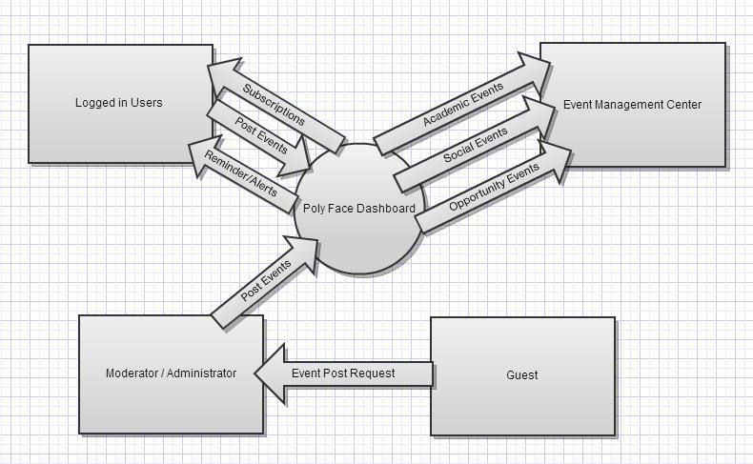

**6. FUNCTIONAL REQUIREMENTS ANALYSIS SPECIFICATIONS**

**6.1 System Capability Requirements**

***Capabilities***

**Posting to the Dashboard as a club member**

* Given full posting privileges
* User can post events directly to the club they are involved in
* Users can edit and delete their own posts
* Posts don’t require Administrative Monitoring to post directly to the dashboard
* Users can subscribe to specific types of event postings on the Dashboard whether it be Academic, Social, or just Free Food Alerts
* Users can view reminders for upcoming events

**Posting to the Dashboard without a membership**

* Given limited posting privileges
* Can send a post request, but it must be approved first by Administrators
* Can post about any event (academic/social/opportunity events), as long as it is relevant information. Once again it will be checked by the administrators before posting.

**Posting as an Administrator**

* Administrators have access to posting
* Administrators can approve posting by non-members and can moderate posts by active members
* Administrators have the power to delete or edit postings

**6.2 User Interface Requirements**

User Interface requirements include different data access, user instructions and navigation. Users have different usability requirements depending on if they are moderators, subscribers or guests. Moderators have controls of inner workings of the dashboard such as approving guest posts. Subscribers are users who have been registered to the dashboard and receive specific views of events, alerts and reminders. Guests are not registered into the dashboard and only receive a general view of the dashboard. To differentiate the requirements of each user base, they are separated into user groups. Security facilities and access restrictions will be limited to each user depending on their user group. As for the dashboard presentation, users are granted to post where applicable and be granted the ability to contribute to the dashboard wherever available. Our target audience is students of NYU-Poly and the content presentation of the dashboard should be user–friendly. For help, users are given instructions to fully utilize the dashboard to their desire. Help will be provided as its own option within the dashboard.

**6.3 Component Architecture**

**6.3.1 Component Architecture**

Account Component - If you hold an account you can post without having the overhead of Administrators

* + Person Interface (required)

uses the majority of the other interfaces

* + Post Interface

used by the person interface

* + Post Viewing Interface

Non-Account Component - same as account component except with limited posting capabilities

* + Person Interface (required)
  + Post Interface
  + Post Approval Interface
  + Post Viewing Interface

**6.3.2 Component Architecture Diagram**

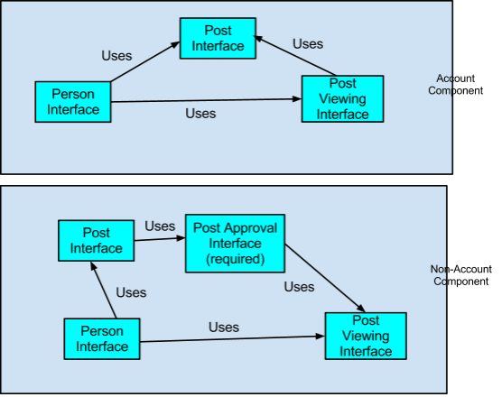

**6.4 Class Diagrams**

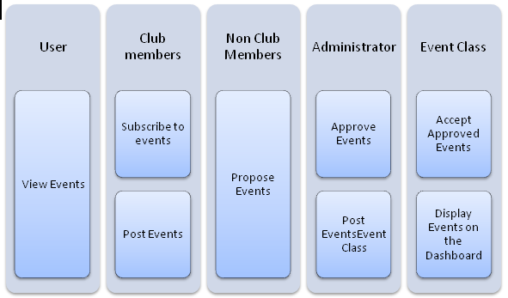

**6.5 Class Relationship/Interaction Diagrams**

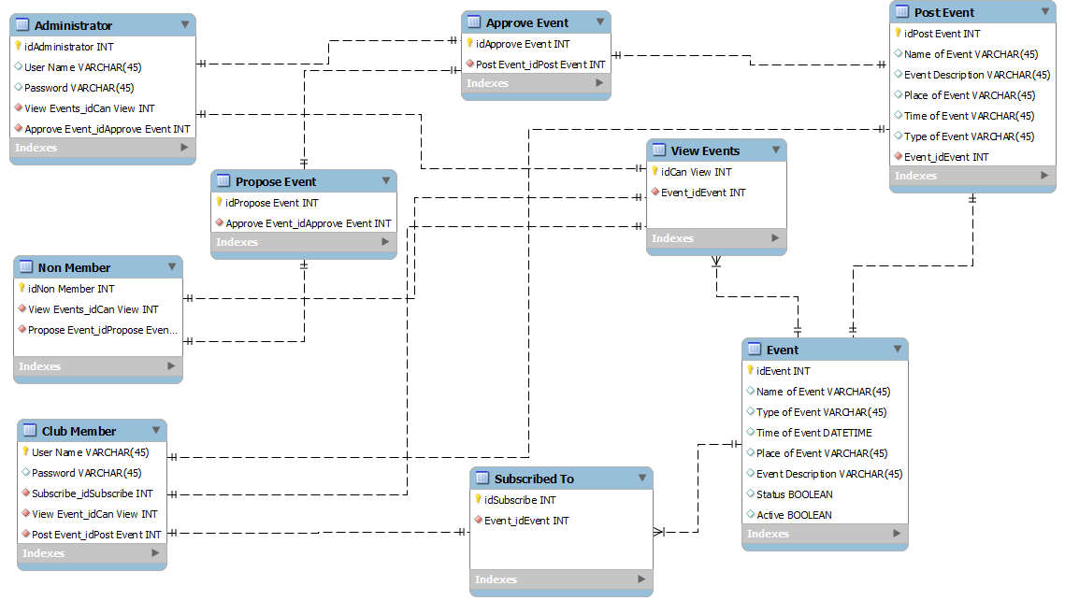

**6.6 Event Section**

**6.6.1 Event Dictionary**

* 1. Class Users: Models all users that the system interacts with
  2. Class Members: Models users that are capable of logging in.
  3. Class Guests: Models users that have no log in information.
  4. Class Posts: Models all submissions and events.
  5. Class Admin: Models the system administrator.
  6. Class polyFace: Models the system itself.
  7. Method submit: This function allows members to directly post event information to the system. The event information is sent as a string to the polyFace system.
  8. Method propose: This function allows non-members(guests) to send their event information to the administrator for approval. Once approved, the information will show on the system.
  9. Method approval: This function provides the administrator with the capability of approving or denying the event proposal of a guest. It returns true if the proposal is approved and false otherwise.
  10. Method logIn: This function sends the Id and password of the member to the polyFace system for verification.
  11. Method verify: This function verifies that the Id and password it is passed, exists in the system. If the log in information exists, then the function returns true, otherwise it returns false.
  12. Method view: This function is shared by all users and allows them to view the event information found in class Posts.
  13. Attribute status: This attribute declares whether or not a submission to the system has been approved. It holds a default value of false.
  14. Attribute active: This attribute declares whether or not an event has passed. If the date of the event has passed then this variable will be set to false, indicating that it should not be active in the system.
  15. Attribute type: This attribute declares what category of event the submission is (Academic, Social, Opportunity, etc).
  16. Attribute id: This attribute holds the value of the member’s user name.
  17. Attribute password: This attribute holds the value of the member’s password.

**6.6.2 Event Diagrams**

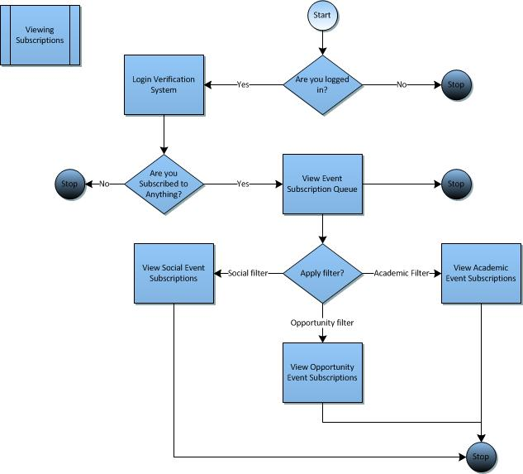

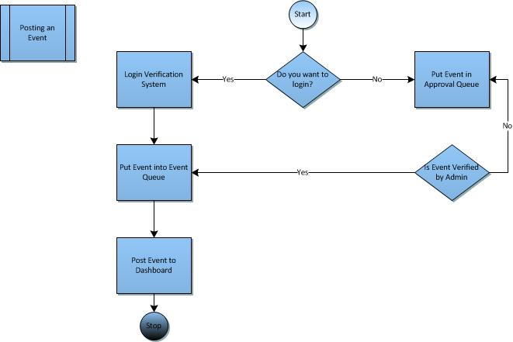

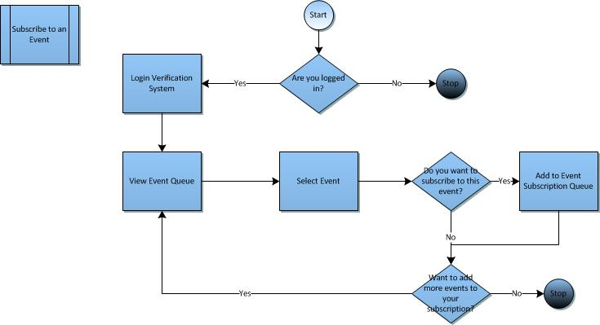

**6.7 Activity/State (Scenario) Section (To be completed in design)**

**6.7.1 Activity (Scenario) Diagrams**

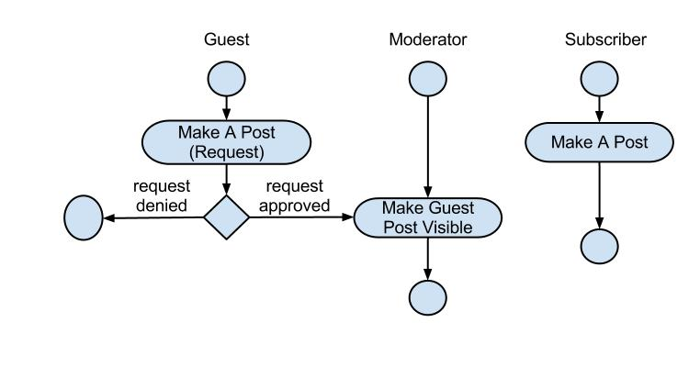

**6.7.2 Activity (Scenario) Specification**

* Guest Process
  + The guest begins by creating a post & putting that post up for request
  + That request is handed over to the moderator of the dashboard
  + There are two possibilities for that request, approved or denied.
  + If the submitted request is denied that is the end of the process
  + If the submitted request is approved then that post will end up on the dashboard
* Moderator Process
  + The moderator’s process consists of the moderator awaiting post requests to approve & upon approval makes those posts visible on the dashboard
* Subscriber Process
  + The subscriber process consists of the subscriber making a post on to the dashboard. There is no over head because the subscriber is an approved member of the PolyFace Dashboard

**6.8 Sequence Diagrams**

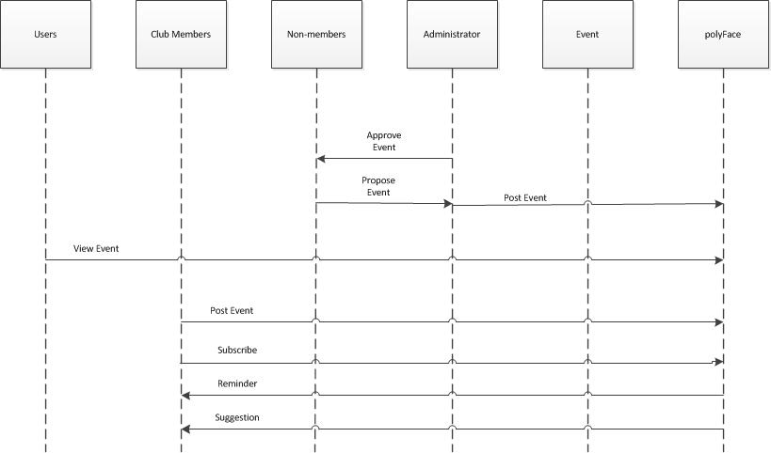

**6.9 Collaboration Diagrams**

N/A until the functions/classes/ methods are written

**6.10 Dictionaries (See 6.6.1)**

**7. NON-FUNCTIONAL/ OPERATIONAL REQUIREMENTS**

**7.1 System External Interface Requirements**

Our system will not make any connection with external sources. All information will be taken from the user or administrators.

**7.2 Safety Requirements**

The log in information of the users must be kept confidential.

**7.3 Security and Privacy Requirements**

Input from guests will reviewed by administrators prior to the display of their posts.

**7.4 System Environment Requirements**

The PolyFace system must be used in a Google Chrome, Internet Explorer, or Mozilla Firefox environment.

**7.5 Computer Resource Requirements**

***7.5.1 Computer Hardware Requirements***

No specific requirements.

***7.5.2 Computer Hardware Resource Requirements***

No specific requirements.

***7.5.3 Computer Software Requirements***

Mozilla Firefox 17.0.1

Google Chrome 23.0

Internet Explorer 9.0

***7.5.4 Computer Communications Requirements***

No specific requirements.

**7.6 System Quality Factors**

Functionality, reliability, maintainability, and usability. The product will be considered functional if it can accommodate every use case. Reliability and usability of the product will be determined by the feedback from the users, while maintainability will be determined by the level of cohesion and coupling in the modules.

**7.7 Design and Construction Constraints**

Our team will face four constraints while they undergo construction and design. Budget, deadlines, safety, and security. The budget of our project will determine the functionality of the site in the sense that the budget will determine things like what type of web hosting we get and how many users we will be able to support on our infrastructure. Deadlines will determine how quickly the project will be completed while safety and security will determine what practices we put into action during implementation.

**7.8 Personnel-Related Requirements**

At least a team of 3 engineers: back-end engineer, front-end engineer, and a software engineer.

**7.9 Training-Related Requirements**

No specific requirements.

**7.10 Logistics-Related Requirements**

No specific requirements.

**7.11 Packaging Requirements**

No specific requirements.

**7.12 Precedence and Criticality Requirements**

No specific requirements.

**7.13 Other Requirements**

No specific requirements.

**8. SYSTEM TEST PLAN REQUIREMENTS**

The software will be passed on to the Software Quality Assurance (SQA) team for testing. The SQA team will be testing our software in a series of inspections as opposed to walkthroughs. Inspections follow a 5-step process: Overview, Preparation, Inspection, Rework, and Follow-up.

This formal and rigid way of testing will allow this process to effectively measure and improve the quality of the software. The structured process will consist of going through each of the use cases to ensure that the actual output is the expected output. The SQA team will note down the number of defects and errors and report back to us [the developers].

**9. QUALIFICATION PROVISIONS**

The Software Analysis Specification (SAS) document will be checked on three levels for quality. First, each team member will check the components that they were responsible for grammatical errors, consistency with the project proposal, and content. Next all the components will be sent to one team member for consolidation and then another round of reviewing. Now that the document has been consolidated and checked, it will be sent out to the SQA group for testing. All faults in the document will be pointed out to the consolidator of the document, whom will make the editions and release the document.

**10. REQUIREMENTS TRACEABILITY**

|  |  |  |
| --- | --- | --- |
| Requirements | Requirement Number | Use Case |
| Given full posting privileges as a club executive board membership holder | REQ - 001 | 7.2.0-1 |
| Freedom ONLY to post about that particular club’s events as a club executive board membership holder | REQ-002 | 7.2.0-1 |
| Post don’t require Administrative Monitoring as a club executive board membership holder | REQ - 003 | 7.2.0-1 |
| Given limited posting privileges if user does not hold club membership | REQ-004 | 7.2.0-2 |
| Can send a post request but it must be approved by Administrators if user does not hold club membership | REQ-005 | 7.2.0-2 |
| Users without club membership can post about any event, as long as it is relevant information | REQ-006 | 7.2.0-2 |
| The Academic Record of Events will update users on upcoming study sessions, tutoring sessions, project opportunities, review sessions, and stress relief related events. | REQ-007 | 7.2.0-3.1 |
| For further opportunities, the Academic Record of Events also be posting dates of career fairs, info sessions, mock interviews,internship opportunities and networking events | REQ-008 | 7.2.0-3.2 |
| The system administrator will post social events according and relating to holidays will be posted | REQ-009 | 7.2.0-3.2 |
| Student gathering including club events, meets and greets,networking opportunities, movie nights, etc. will be notified on the dashboard by the system administrator | REQ-010 | 7.2.0-3.2 |
| Reminders will consist of all categories, but mostly for academic calendar specific reminders. | REQ-011 | 7.2.0-4 |
| The dashboard will notify the users of all events at which there will be free food | REQ-012 | 7.2.0-6 |

**13. APPENDICES**

**13.1 Dictionaries**

(N/A the simplest of terms used in writing this document)

**13.2 UML diagrams, if not included in the body of the document**

(Included in documentation)

**13.3 Schedule Tracking**

|  |  |  |  |  |
| --- | --- | --- | --- | --- |
| **Artifact/ Deliverable** | **Who** | **Estimated** | **Actual** | **Difference** |
| RAS Compilation | Wendy Lau | 2 hours | 1.5 hours | .5 hours |
| RAS | Basia Bowens | 2 hours | 2 hours | 0 hours |
| RAS | Wayne Jones | 2 hours | 2 hours | 0 hours |

**Cumulative Totals**

|  |  |  |  |
| --- | --- | --- | --- |
| **Who** | **Estimated** | **Actual** | **Difference** |
| Basia Bowens | 4½ hours | 3 ½ Hours | 1 hour |
| Wayne Jones | 3 hours | 5 hours | 2 hours |
| Wendy Lau | 3 hour | 2 ½ hours | .5 hours |

**13.4 Defect Tracking**

|  |  |  |  |  |
| --- | --- | --- | --- | --- |
| **Artifact/ Deliverable** | **Who** | **Estimated** | **Actual** | **Difference** |
| RAS | Wendy Lau | 2 |  |  |
| RAS | Basia Bowens | 3 |  |  |
| RAS | Wayne Jones | 3 |  |  |

**Cumulative Totals**

|  |  |  |  |
| --- | --- | --- | --- |
| **Who** | **Estimated** | **Actual** | **Difference** |
| Basia Bowens | 3 |  |  |
| Wayne Jones | 3 |  |  |
| Wendy Lau | 3 |  |  |

**Gantt Chart/ Project Schedule**

